**Electrical Installations and loads**

**Task 1: Understanding wires and protective devices**

Using the wires provided, please fill in the following table:

|  |  |  |  |  |
| --- | --- | --- | --- | --- |
| **Wire size (mm2)** | **Number of strands (please count)** | **Diameter of one strand (mm)** | **Total area**  **(mm2)** | **Resistance per meter length(×10-3Ωm-1)** |
| **1** | **1** | **1.13** | **1.0029** | **16.7514** |
| **1.5** | **7** | **0.53** | **1.5443** | **10.8787** |
| **2.5** | **7** | **0.67** | **2.4680** | **6.8071** |
| **4** | **7** | **0.85** | **3.9722** | **4.2294** |

Please note that the resistivity of Cu is 16.8 nΩ·m

**Task 2: Understanding the protective devices**

Using the following-coloured parts of the CB, write down the operation of each part:

|  |  |
| --- | --- |
|  | **Latch** – mechanically holds the contacts closed. Allowing current to flow. When tripped latch releases, causing contact to separate  **Solenoid**- Solenoid creates a big magnetic field when a large current passes through it, which move plunger and move the latch, which open the circuit then. |
|  | Made of two distinct metals, it heats up when current flowing through it. It designed in a way that after a certain predefined current it bends such that the latch will trigger, which cause to open the circuit. |
|  | When the MCB contacts released, an electrical arc can form. This arc chutes is designed to dissipate this arc safely. |

Write ‘True’ or ‘False’ under each of the following statements related to an MCB (Miniature Circuit Breaker) or MCCB (Moulded Case Circuit Breaker):

|  |  |
| --- | --- |
| The circuit breaker should continuously carry the normal load current | **True** |
| The circuit breaker must detect fault conditions and promptly interrupt the fault current | **True** |
| The circuit breaker should not be damaged during the arc quenching process that occurs when interrupting fault currents | **True** |
| After a fault is cleared, an automatic or manual mechanism should be available to restore the circuit's operation | **True** |

Perform the following calculation for a single-phase circuit powering a 5 kW oven:

|  |  |
| --- | --- |
| Possible voltage to which the over is connected | 230V |
| Possible power factor (of the oven. Please remember that an over carries a resistive element and current and voltage waveforms are in-phase. That is | 1 |
| Using the equation , calculate the current drawn by the oven | 21.74A |
| Using available MCB sizes (look on the internet) select an MCB such that the MCB rating is greater than the load current | 32A |

* Describe the operation of an RCCB with a diagram

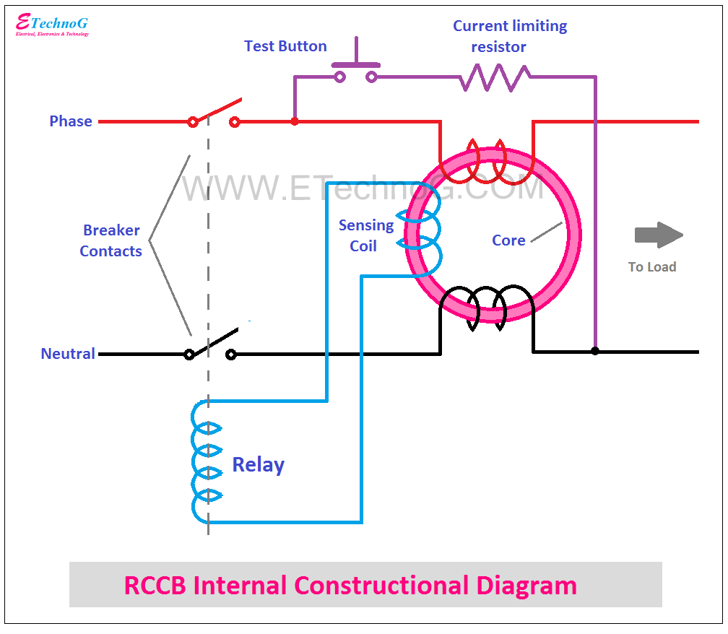

An RCCB works by comparing the current in the phase and neutral wires, which pass through a common sensing coil. Under normal conditions, both currents are equal, so their magnetic fields cancel out. If a leakage occurs (like current flowing to the ground through a person), the balance breaks. This imbalance induces a current in the sensing coil, triggering the relay. The relay then trips the breaker, cutting power—usually in under 30 ms—preventing electric shocks and hazards.

**Task 3: Wiring System**

In this experiment, you will utilize the existing electrical installation to connect the circuits depicted in the following figure.

* + Circuit 1: A radial lamp circuit.
  + Circuit 2: A radial socket outlet circuit.
  + Circuit 3: A ring socket outlet circuit.



* Based on the details provided in the diagram, your observation of the laboratory setup components, and verification of the provided wiring, connect both circuits.
* Present these completed circuits to the instructor for inspection.
* Test the functionality of the connected circuits by connecting the different appliances given abd measuring the current.
* Subsequently, disconnect the main power supply to the distribution board (DB).

**Task 4: Design the Electrical System**

**Objective:** To apply electrical wiring principles to design a safe and functional electrical system for a residential building.

**Material:** Floor plans

|  |  |
| --- | --- |
|  |  |
|  |  |

**Activity Steps:**

Step 1: List the appliances/items in each room

|  |  |
| --- | --- |
| *Room* | *Description of electrical items in each room (lamps, fans, socket outlets, special appliances)* |
|  |  |
|  |  |
|  |  |
|  |  |
|  |  |
|  |  |
|  |  |
|  |  |

Step 2: Implementing the plan with electrical items

Implement the plan assigned to your group in <https://floorplanner.com/projects>

* Implement the plan on the ‘floorplanner. ’
* Plan the layout of electrical outlets, switches, and lighting fixtures on the floor plan.
* Using the Place Sign and Symbols tab, indicate the locations of switches, plug sockets, lamps, and fans.

Step 3: Develop an Excel sheet with the following subheadings

For each sub-circuit that you designed, develop an Excel sheet with the following subheadings:

* Circuit No ✅
* Ring/ Radial ✅
* Description ✅
* Diversity factor ✅
* Maximum demand (A) ✅
* Rating of the MCB (A) ✅
* Length of the circuit (m) ✅
* Min Current Carrying Capacity ✅
* Ambient temperature factor ✅
* Grouping factor ✅
* Initial wire selection (mm2) ✅
* Voltage drop ✅
* Check whether the VD < allowable value✅
* If required, Second wire selection & Voltage drop

Propagate the Excel sheet for each circuit

Step 4: Create a detailed wiring diagram showing the connections between the electrical components and the distribution panel.

**DATA:**

TABLE A: Diversity factors

|  |  |  |  |
| --- | --- | --- | --- |
| **Final circuit** | **Household installations** | **Small shops, stores, offices and business premises** | **Small hotels. Boarding houses, guest houses** |
| Lightning | 66% of TD | 90% of TD | 75% of TD |
| Cooking appliances | If FL < 10 A  10 A + 5A if a SO is incorporated  If FL > 10 A  10 A + 30% of FL + 5A if a SO is incorporated | X + 0.8Y+0.6Z | X + 0.8Y+0.6Z |
| Motors | N/A | X + 0.8Y+0.6Z | X + 0.8Y+0.6Z |
| Instantaneous water heaters | X+Y+0.25Z | X+Y+0.25Z | X+Y+0.25Z |
| Thermostatically controlled water heaters | 100% of FL | 100% of FL | 100% of FL |
| Standard or final circuits with SOs | X+0.4(Y+Z) | X+0.5(Y+Z) | X+0.5(Y+Z) |
| SO other than Standard circuits | X+0.4(Y+Z) | X+0.7(Y+Z) | X+0.7W+0.4Z |

where TD is the total current demand; FL is the full load; SO is the socket outlet; X is the largest appliance/circuit; Y is the second largest; Z is the remaining; W is the SOs in living and dining rooms

TABLE B: Final circuits using square socket-outlets

|  |  |  |  |
| --- | --- | --- | --- |
| **Type of circuit** | **Over current protective device** | **Minimum live conductor cross sectional area (mm2)** | **Maximum floor area served (m2)** |
| Ring | 30 or 32 A | 2.5 | 100 |
| Radial | 30 or 32 A | 4.0 | 75 |
| Radial | 20 | 2.5 | 50 |

TABLE C: Current carrying capacities and associated voltage drops for single-core p.v.c insulated cables, non-armoured, copper conductors enclosed in conduit or trunking:

|  |  |  |  |  |
| --- | --- | --- | --- | --- |
| Cross sectional area (mm2) | 2 cables single phase ac or dc | | 3 or 4 cables three phase ac | |
| Current (A) | Drop in mV/Amp-meter | Current (A) | Drop in mV/Amp-meter |
| 1.0 | 13.5 | 44.0 | 12.0 | 38.0 |
| 1.5 | 17.5 | 29.0 | 15.5 | 25.0 |
| 2.5 | 24.0 | 18.0 | 21.0 | 15.0 |
| 4.0 | 32.0 | 11.0 | 28.0 | 9.5 |
| 6.0 | 41.0 | 7.3 | 36.0 | 6.4 |
| 10.0 | 57.0 | 4.4 | 50.0 | 3.8 |
| 16.0 | 76.0 | 2.8 | 68.0 | 2.4 |
| 25.0 | 101.0 | 1.8 | 89.0 | 1.5 |
| 35.0 | 125.0 | 1.3 | 110.0 | 1.1 |

Ambient temperature 300 C

TABLE D: Ambient temperature factor

|  |  |  |  |  |  |  |  |  |
| --- | --- | --- | --- | --- | --- | --- | --- | --- |
| Ambient temperature oC | 25 | 30 | 35 | 40 | 45 | 50 | 55 | 60 |
| Factor | 1.03 | 1 | 0.94 | 0.87 | 0.79 | 0.71 | 0.61 | 0.50 |

TABLE E: Grouping factor

|  |  |  |  |  |  |  |  |  |
| --- | --- | --- | --- | --- | --- | --- | --- | --- |
| Number of circuits | 1 | 2 | 3 | 4 | 5 | 6 | 7 | 8 |
| Factor | 1.0 | 0.8 | 0.7 | 0.65 | 0.6 | 0.57 | 0.54 | 0.52 |

1. **Description about each part of the house**

***Step 1: Description about each part of the house***

**Living Room**Six 10W LED lamps  
Two 10W wall lamps  
Four 13 A plug sockets   
One 75 W ceiling fan

**Dining and Pantry**Two 5W LED lamps  
Two 10W LED lamps  
One 15W LED lamp  
Four 13 A plug sockets  
One 75 W ceiling fan  
One 2kW Oven  
One 2kW Rice Cooker  
150W Fridge

**Bedroom 1**One 10 W LED lamps   
One 13 A plug sockets  
One 75W Fan

**Bedroom 2**One 10 W LED lamps   
One 13 A plug sockets  
One 75W Fan

**Bedroom 3**Two 10 W LED lamps   
Two 13 A plug sockets  
Two 5W LED lamps  
One 1.2kW A/C

**Toilet**One 10W LED lamp  
One 5W LED lamp  
One 1 kW instantaneous water heater  
Two 13A plug sockets

**Garage**Two 10W LED lamp  
One 15W LED lamp  
Two 13A plug sockets

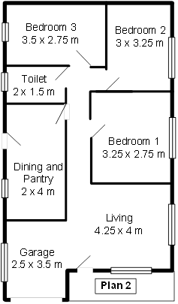

***Step 2: The plan with electrical items***

|  |  |  |
| --- | --- | --- |
| **Circuit No** | **Ring / Radial** | **Description** |
| ***Lighting*** | | |
| 1 | Radial | * One 10 W LED lamps in bedroom 1 * One 10 W LED lamps in bedroom 2 * Two 10W and 5W LED lamps in bedroom 3 |
| 2 | Radial | * Two 5W LED lamps in the dining & pantry * Two 10W LED lights in dining & pantry * One 15W LED lamp in the dining & pantry |
| 3 | Radial | * One 10W LED and One 5W LED in Toilet * Two 10W LED and 5W wall lamp in the Corridor |
| 4 | Radial | * Six 10W LED lamps and two 5W wall lamps |
| 5 | Radial | * Two 10W LED lamps and one 15W lamps |
| ***Socket Outlets*** | | |
| 6 | Ring | * One 13A socket in bedroom 1 * One 13A socket in bedroom 2 * Two 13A sockets in bedroom 3 * Two 13A sockets in toilet |
| 7 | Radial | * Four 13A sockets for dining & pantry * Four 13A sockets in living room * Two 13A sockets in garage |
| 8 | Radial | * A dedicated socket for 150W fridge in the kitchen |
| 9 | Radial | * A dedicated socket for 2kW oven in the kitchen |
| 10 | Radial | * A dedicated socket for 2kW rice cooker in the kitchen |
| 11 | Radial | * A dedicated socket for 1kW instantaneous water heater in the toilet |
| 12 | Radial | * A dedicated socket for 1.2kW A/C in the bedroom 3 |
| Ceiling fan circuits | | |
| 13 | Radial | * One 75 W ceiling fan in living room * One 75 W ceiling fan in dining & pantry * One 75 W ceiling fan in bedroom 1 * One 75 W ceiling fan in bedroom 2 |

***Step 3: Wiring calculations***

**1. Description of circuit sub-divisions**

|  |  |  |  |
| --- | --- | --- | --- |
| Circuit Number | Calculation considering the Diversity factors | Max current demand/A | MCB rating/A |
| 1 |  | 0.26 | 6 |
| 2 |  | 0.19 | 6 |
| 3 |  | 0.11 | 6 |
| 4 |  | 0.23 | 6 |
| 5 |  | 0.10 | 6 |
| 6 | - | - | 32 |
| 7 | - | - | 32 |
| 8 |  | 0.65 | 6 |
| 9 |  | 8.70 | 10 |
| 10 |  | 8.70 | 10 |
| 11 |  | 4.35 | 10 |
| 12 |  | 5.22 | 6 |
| 13 |  | 1.30 | 6 |

**2. Diversity factors, Max current and MCB rating demand in each circuit**

**3. RCCB Selection**

|  |  |
| --- | --- |
| RCCB | Assigned circuits to the RCCB |
| 40A, 30mA | 1 |
| 2 |
| 3 |
| 4 |
| 5 |
| 6 |
| 40A, 30mA | 9 |
| 10 |
| 11 |
| 12 |
| 40A, 30mA | 7 |
| 8 |
| 13 |

**4. Wire Sizes**

|  |  |  |  |  |  |  |  |
| --- | --- | --- | --- | --- | --- | --- | --- |
| Circuit Number | Number of circuits in the conduit | Cg | Minimum CCC / A | Maximum wire length/m | Voltage drop / V | L and N Conductor size (mm2) | Protective conductor size (mm2) |
| 1 | 3 | 0.7 |  | 25 |  | 1.0 | - |
| 2 | 2 | 0.8 |  | 9 |  | 1.0 | - |
| 3 | 2 | 0.8 |  | 11 |  | 1.0 | - |
| 4 | 2 | 0.8 |  | 15 |  | 1.0 | - |
| 5 | 2 | 0.8 |  | 10 |  | 1.0 | - |
| 6 | 3 | 0.7 | - | 21 | - | 2.5 | 2.5 |
| 7 | 2 | 0.8 | - | 27 | - | 2.5 | 2.5 |
| 8 | 3 | 0.7 |  | 4 |  | 1.0 | 2.5 |
| 9 | 3 | 0.7 |  | 5 |  | 1.5 | 2.5 |
| 10 | 3 | 0.7 |  | 4 |  | 1.5 | 2.5 |
| 11 | 2 | 0.8 |  | 4 |  | 1.0 | 2.5 |
| 12 | 3 | 0.7 |  | 5 |  | 1.0 | 2.5 |
| 13 | 2 | 0.8 |  | 25 |  | 1.0 | 2.5 |

* Allowable voltage drop is 3%. Therefore, allowable voltage drop = = 6.9 V
* Ambient temperature factor was taken as 0.94 at 35 oC

**­­­­­**

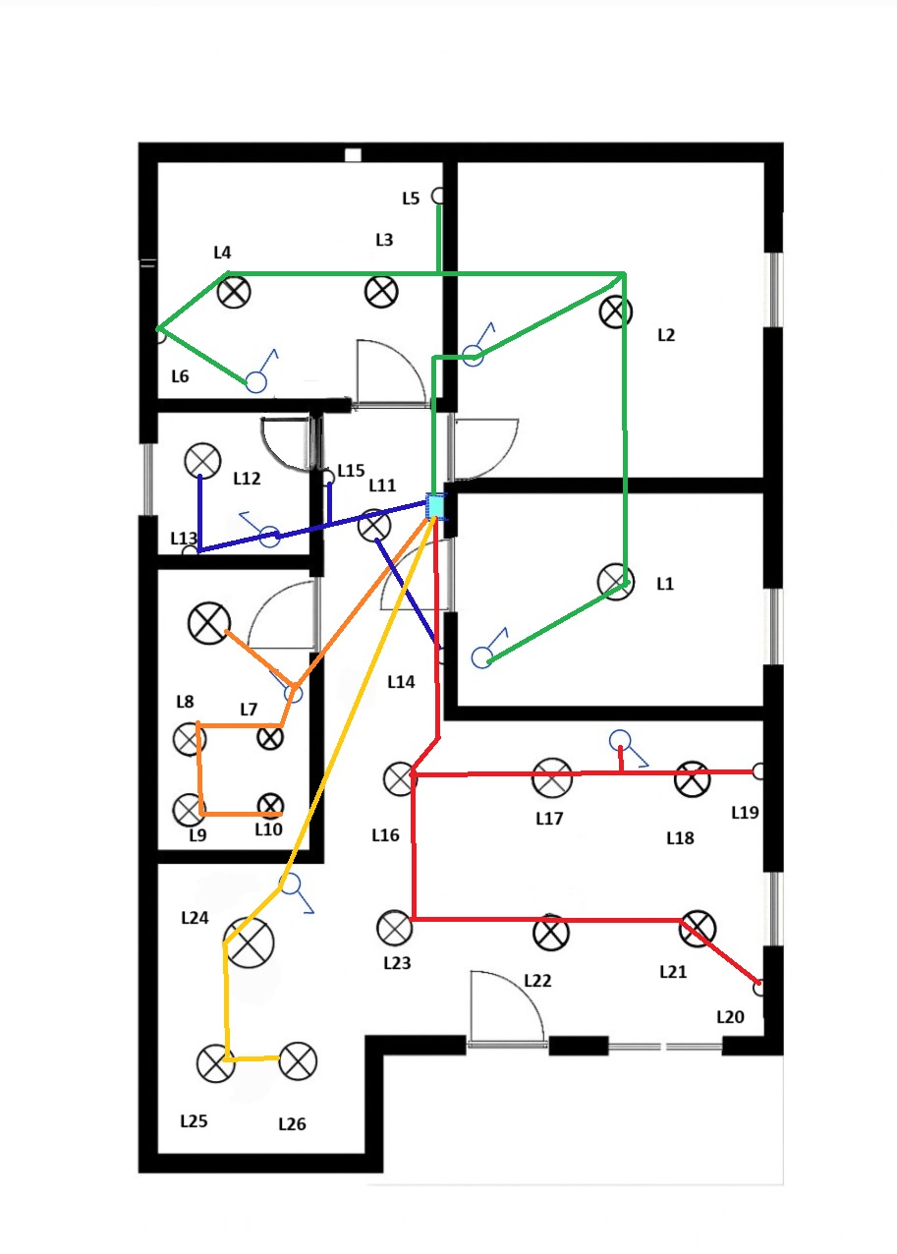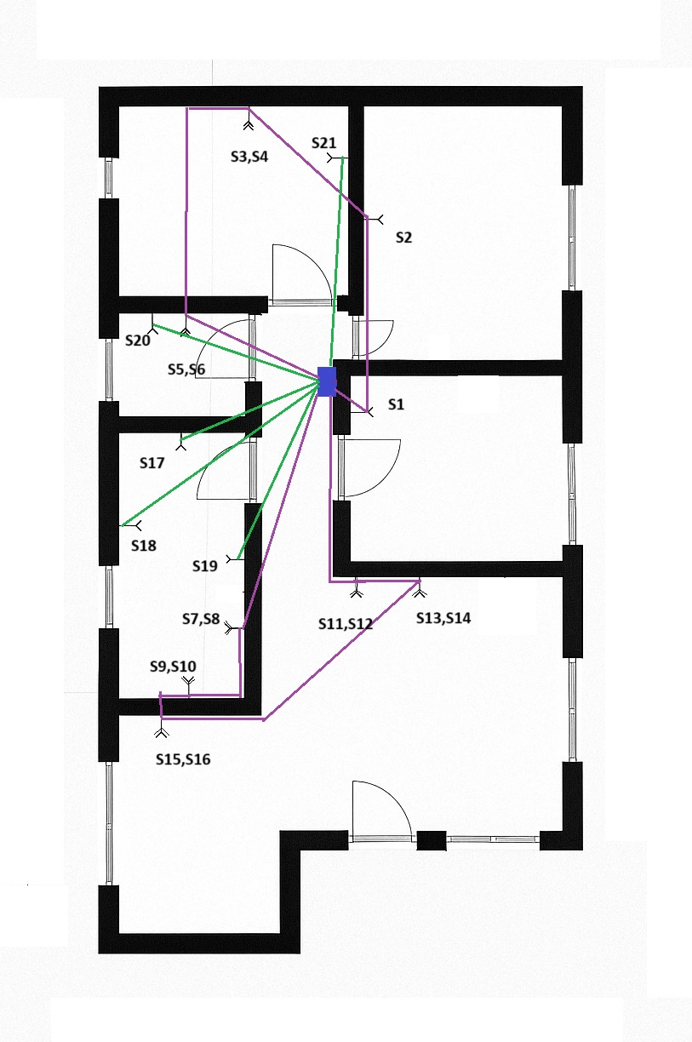

***Step 4: Wiring diagrams***

**Lamp layout with switches**

**Sockets outlet layout**

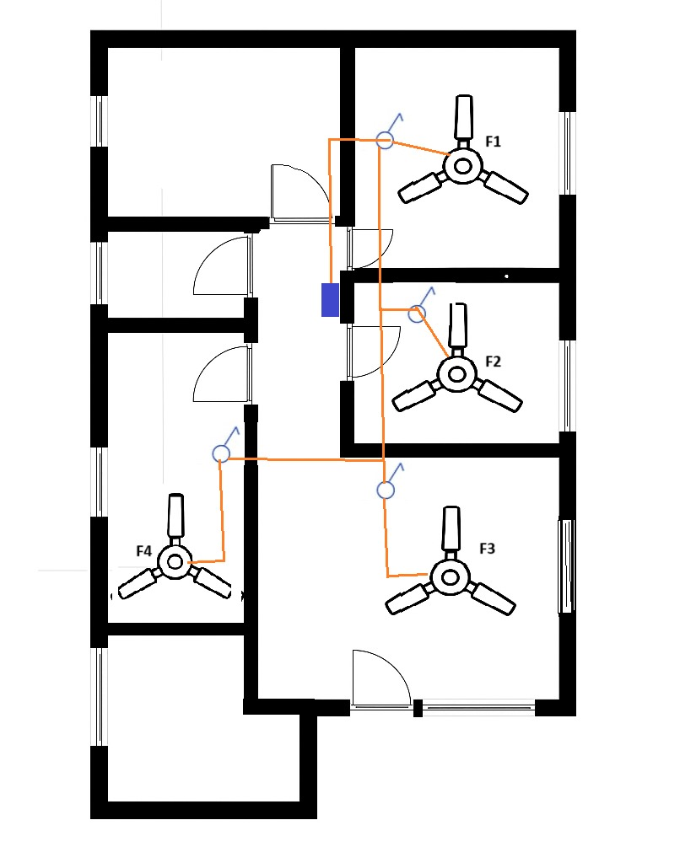

Dedicated circuit

Ring circuit

Radial circuit

Plug socket

LED lamp

Switches

Ceiling Fan

Distribution Box

**Fan layout**



**Conduit layouts**

Conduit layout for lights

¾” Conduit

1” Conduit

Conduit layout for sockets outlet

Final conduit layout



**RCCB   
40 A**

1

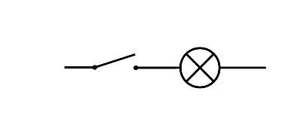

L1



L2

L3

L4

L5

**6-way MCB**

L7

1/1.13

L6

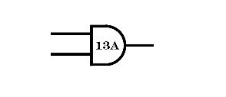

S1

S2

S3



S5

S6

S7

S8



F1

F2

F3



12

1/1.13



S13

S14

S9

S15

S16

S17

S18



S10

S11

S4

S12

4

7/0.67

5

6

7/0.67

7/0.67

3

7/0.67

6A

6A

16A

32A

16A

6A

**9. Diagrams**

**RCCB   
40 A**

Conduit layout for sockets outlet

**1**

**2**

**3**

Lighting in dining & pantry

Lighting in bedroom 1, bedroom 2, bedroom 3

L and N- 1 mm2

L and N- 2.5 mm2

40A, 30mA RCCB

Lighting in toilet and corridor

L and N- 2.5 mm2

**4**

Lighting in living room

L and N- 2.5 mm2

**5**

Lighting in garage

L and N- 2.5 mm2

**6**

Plug sockets in bedroom1, bedroom2, bedroom3 and toilet

L and N- 2.5 mm2, E – 2.5 mm2

40A, 1P

L and N- 1.5 mm2, E – 2.5 mm2

**10**

**9**

A dedicated line for the 2kW oven in dining & pantry

L and N- 1.5 mm2, E -2.5 mm2

**11**

40A, 30mA RCCB

A dedicated line for the 2kW rice cooker in dining & pantry

A dedicated line for the 1kW water heater in toilet

L and N- 1.0 mm2, E - 2.5 mm2

**12**

A dedicated line for the 1.2kW Air conditioner in bedroom 3

L and N- 1.0 mm2, E – 2.5 mm2

**7**

Plug sockets in dining & pantry, living room, and garage

L and N- 2.5 mm2, E – 2.5 mm2

**8**

A dedicated line for the 150W fridge in dining & pantry

L and N- 1.0 mm2, E -2.5 mm2

**13**

40A, 30mA RCCB

Fans in the bedroom 1, bedroom 2, living room, dining & pantry

L and N- 1.0 mm2, E - 2.5 mm2

**Approximate Costs (in rupees)**

*Note that the costs are given in LKR

|  |  |  |  |
| --- | --- | --- | --- |
| 1 mm2 wire (100 m) | Rs. 5000 – single core | Ceiling roses | Rs. 275 |
| 1.5 mm2 wire (100 m) | Rs. 20000 – two core | 13A socket | Rs. 900 |
| 2.5 mm2 wire (100 m) | Rs. 30000 – two core | Switches | Rs. 300 per gang |
| Earth wires (100 m) | Rs. 15000 | MCB | Rs. 800 |
| Fan | Rs.13000 | Conduits 1” | Rs. 750 per m |
| Main switch | Rs. 2500 | Conduits 3/4” | Rs. 500 per m |
| RCCB | Rs. 4800 | Holder | Rs. 225 |
| Bends, Plastic boxes, junction boxes | Rs. 100 | LED lamp | Rs.2000 – 5W wall lamp  Rs.1000 – 5W  Rs.1500 – 10W  Rs.2000 – 15W |

Workmanship fees – Rs.750 per point

**Bill Of Quantities (BOQ)**

1. For ring plug circuit

|  |  |
| --- | --- |
|  | For circuit 5 (15m) |
| For plug sockets | 5400 |
| Cost for L and N wires | 9000 |
| Cost for Earth wires | 2250 |
| Cost for conduit (Took 60% of wire length) | 6750 |
| Cost for bends, plastic boxes, junction boxes | 300 |
| Workmanship fees | 750x6 = 4500 |
| Total | 28200 |

Total cost for ring plug circuits = 28200

1. For radial plug circuits

|  |  |  |
| --- | --- | --- |
|  | For circuit 10 (5m) | For circuit 4 (12m) |
| For plug sockets | 900 | 4500 |
| Cost for L and N wires | 500 | 7200 |
| Cost for Earth wires | 750 | 1800 |
| Cost for conduit (Took 60% of wire length) | 2250 | 5400 |
| Cost for bends, plastic boxes, junction boxes | 100 | 200 |
| Workmanship fees | 750 | 3750 |
| Total | 5250 | 22850 |

Average cost = 14050

Total cost for radial plug circuits = 14050 x 8 = 112400

1. For lightening circuits

|  |  |  |
| --- | --- | --- |
|  | For circuit 1 (20m) | For circuit 2 (30m) |
| For lamps | 15800 | 44700 |
| Cost for L and N wires | 2000 | 3000 |
| Holders | 1575 | 4950 |
| Switches and sunk boxes | 1600 | 1200 |
| Ceiling roses | 1925 | 3025 |
| Cost for conduit (Took 60% of wire length) | 6000 | 9000 |
| Cost for bends, plastic boxes, junction boxes | 700 | 1400 |
| Workmanship fees | 750x7 = 5250 | 750x22 = 16500 |
| Total | 34850 | 83775 |

Total cost for lightening circuits = 118625

1. For Fan circuit

|  |  |
| --- | --- |
|  | For circuit 12 (22m) |
| For Fans | 13000 x 3 = 39000 |
| Cost for L and N wires | 2200 |
| Cost for Earth wires | 1000 |
| Switches and sunk boxes | 1200 |
| Cost for conduit (Took 60% of wire length) | 6600 |
| Cost for bends, plastic boxes, junction boxes | 400 |
| Workmanship fees | 750x3 = 2250 |
| Total | 52650 |

Total cost for fan circuits = 52650

**Total cost**

|  |  |
| --- | --- |
| Description | Cost (rupees) |
| Main switch | 2500 |
| Trip switch | 5000 |
| MCB’s | 9600 |
| Radial plug socket circuits | 112400 |
| Ring plug socket circuit | 28200 |
| Lightening circuits | 118625 |
| Fan circuit | 52650 |
| Total Cost | 328975 |

**Total cost = 328,975 LKR**